COUNTING
KS1 – 2001 Paper
1.
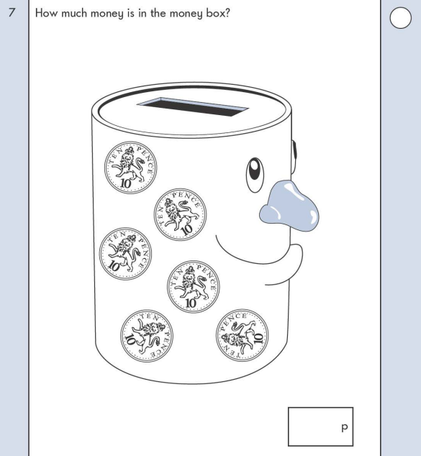
KS1 – 2002 Paper
2.
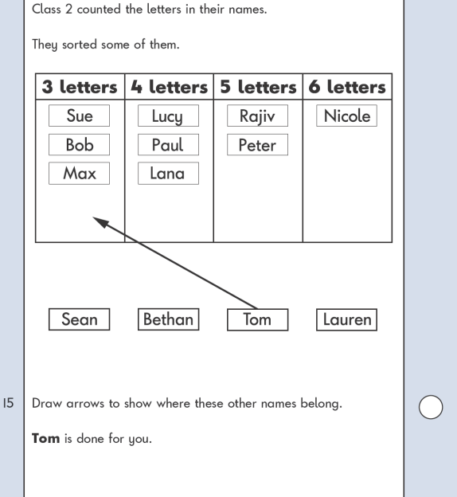
KS1 – 2003 Paper 1
3.
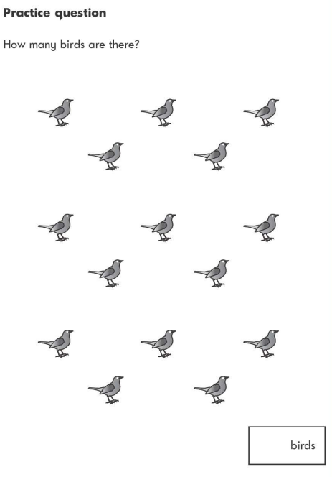

KS1 – 2003 Paper 1
4.
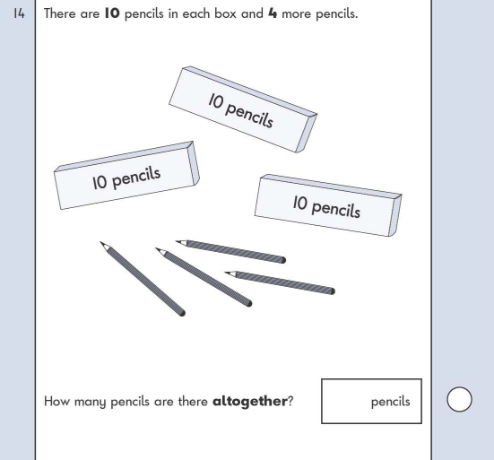
5.
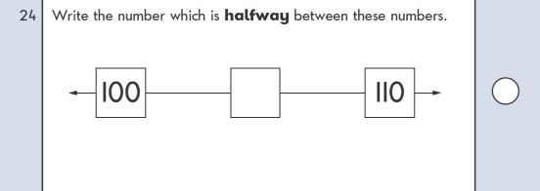
KS1 – 2004 Paper 1
6.

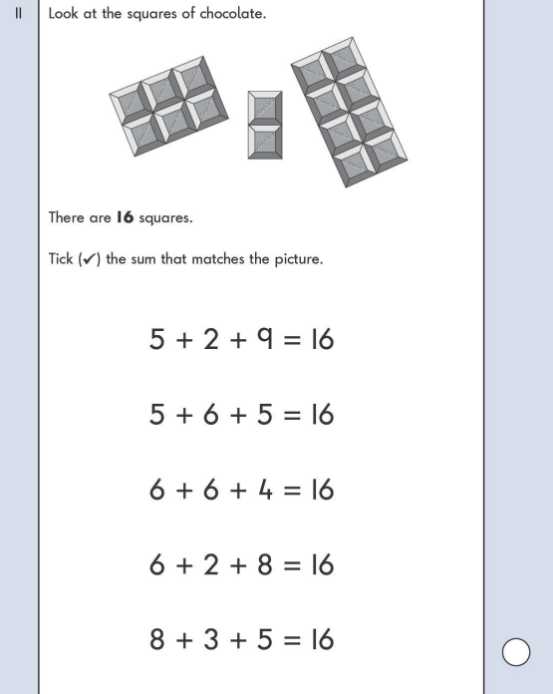

KS1 – 2005 Paper 1
7.
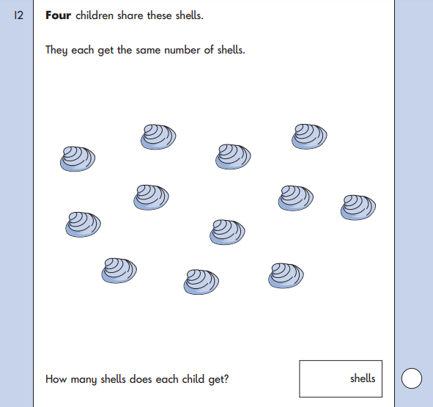

KS1 – 2005 Paper 2
8.
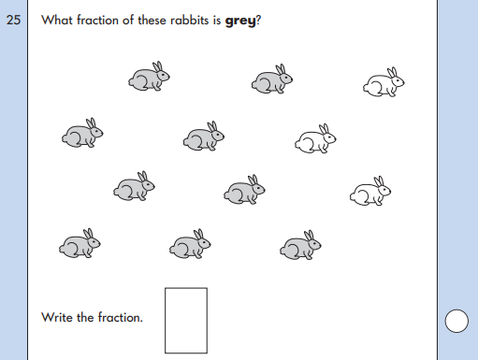

KS1 – 2007 Paper 1
9.
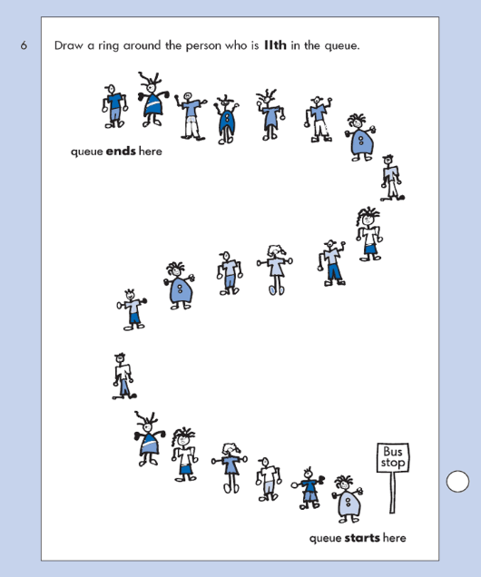

KS1 – 2007 Paper 2
10.

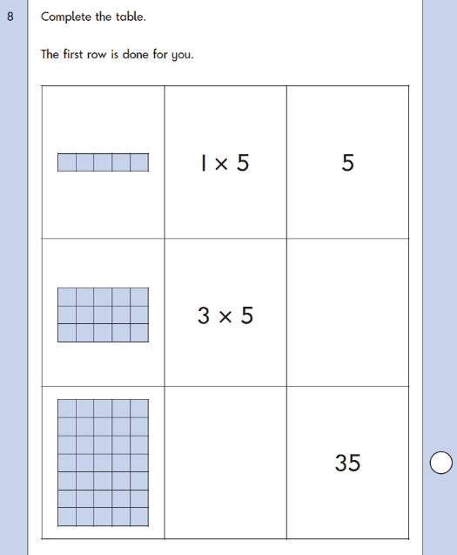
KS1 – 2009 Paper 1
11.

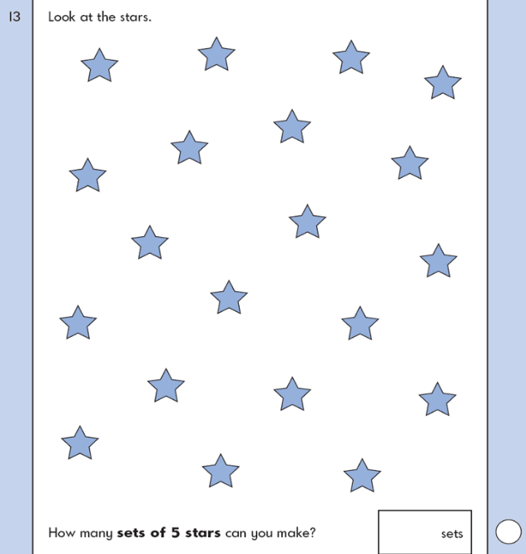
KS1 – 2016 Paper - Reasoning
12.

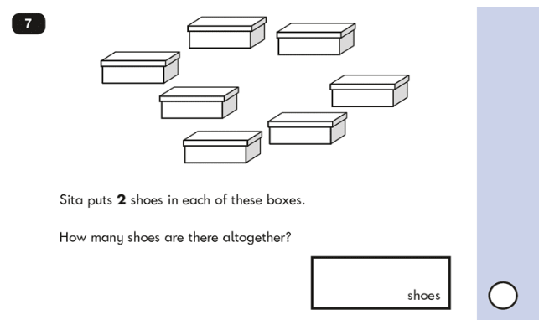
13.
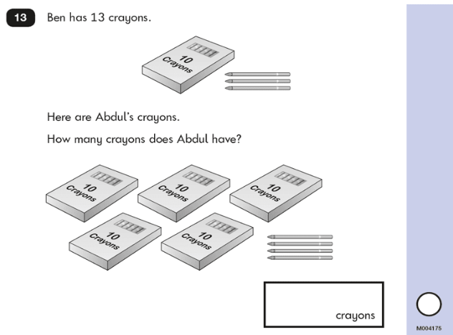
KS1 – 2016 Paper – Reasoning (Second)
14.

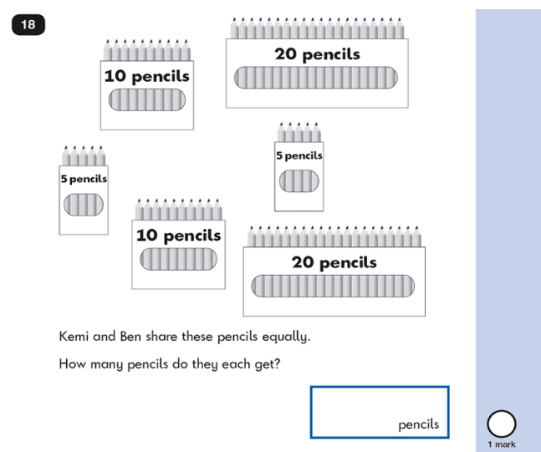
KS1 – 2018 Paper – Reasoning
15.
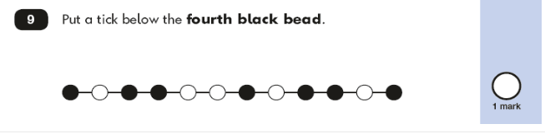
KS1 – 2019 Paper – Reasoning
16.

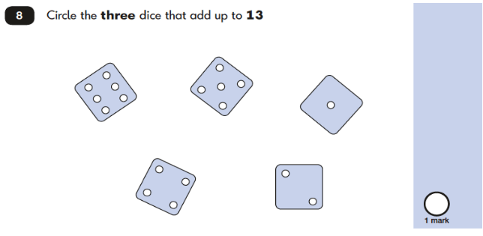
17.
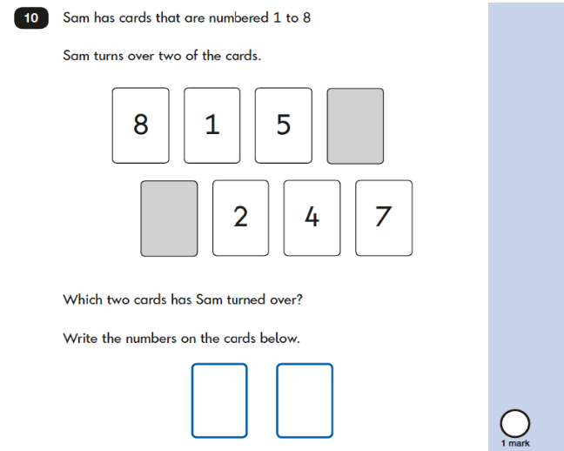
KS1 – 2022 Paper – Reasoning
18.
